**CMC CONVERSION WITH EXISTING CUSTOMERS**

Step 1

* Access the project log request
* Note the comment to see if there is any specified time for a “Go Live” date, determine if it is a big bang or trickle request
* Review the field’s worksheet, text-to-column the provided accounts if they are in text, then sort A-Z, then look for:
  + Any duplicate accounts on the worksheet
  + Any missing data
  + Any specific changes needed when you create the new customer (i.e. phone, contact, delivery date, etc.)
* Create a folder on desktop for all your files and information to be kept together (only a suggestion for best practices)
* Extract the partner functions using /SCL/RDMLS_AUDIT_02 - Customer Master Partner Function and save in your folder as OLD PARTNERS.
* Extract the VPs, this includes Z7, ZR and/or 03, using /SCL/RUOSD_VP_MANAGE - Visit Plan Manager and save each file individually in the folder as OLD Z7, OLD ZR… call customers will not need a CRM pulled for historical data
  + If a FSV conversion, make sure to pull Z1 for those accounts.

Step 2

* Open SAP, access Tcode /SCL/RDMLS_CUS_EXT - Customer Extract Report
  + Go to top bar, select “Goto”>Variants>Get
    - 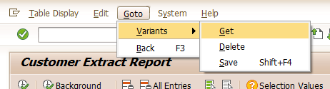
  + Type in the variant search box: CMC EXTRACT, click the green check mark
  + Populate the CUSTOMER field with the customer numbers provided on the worksheet from the project log
  + Click on the green circle check to process the extract report
    - 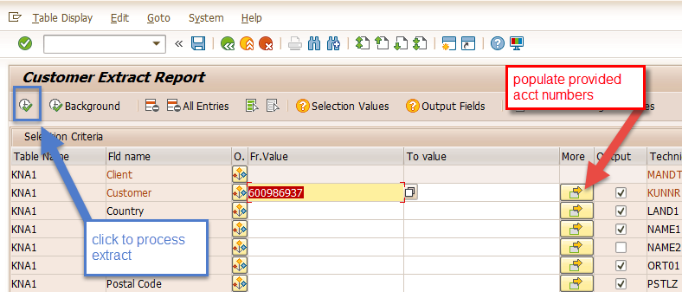
  + Click on the layout icon and select CMC LOAD LAYOUT
    - 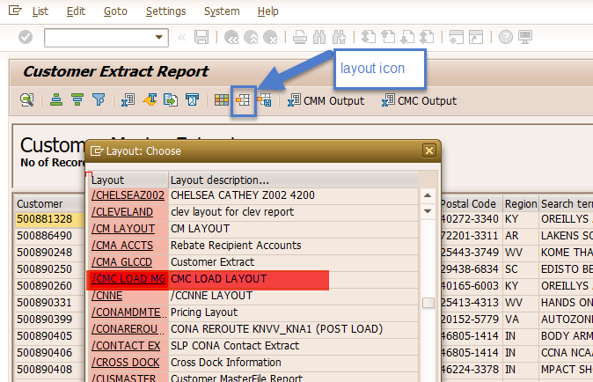
* Export data to a temporary excel worksheet
* Open the *DSD with EDI CMC for EXISTING CUSTOMERS* template
* Populate the extract into the template
  + Review the template
    - Browse all fields to ensure that the data is lined up correctly to the right header, ignore the address section (column J and K) at this time as we will work on that later
    - Column T (Language) will be blank, populate it with the letter “E”
    - Continue to browse the remaining fields to ensure they are all aligned with the header row
    - Discard the temporary extract file, it is no longer needed

Step 3

* Column H: Change the existing account name to the NEW name provided from the field worksheet, noting the new store number if any are provided… If store number is given, then please update column W (Location Code)
  + Make sure to comply with MDM naming standards
* Remove all data in Column I, the system will auto-populate this field when it is being created

*NOTE* I always add an additional tab at the bottom if I need to do additional work, such as concatenate so that I can have a record of EVERYTHING I did to the create process. This is not necessary but would be considered best practice.

* Column K and L: Update Street and House number
  + There is a separate tab called “STREET”
  + Move Column K (Street) to the first column in the STREET Tab. In the STREET Tab:
    - Highlight column A
    - Select “Text to Column” in the Data tab at the top menu bar
    - Select delimited, click NEXT
    - This section already has TAB checked, then check SPACE and OTHER, in the character field Other insert the “|”, straight bar found about the enter button on your keyboard. Click NEXT
    - Destination change to “$B$1”
    - Click Finish
      * 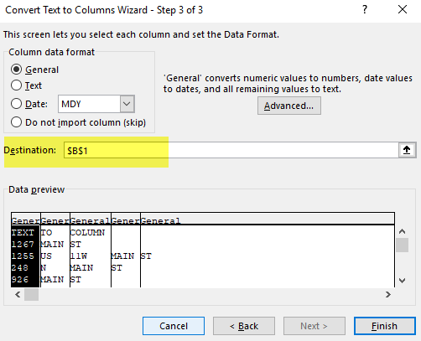
    - A dialog box will pop up “There’s already data here. Do you want to replace it?” CLICK OK
    - Go to column J in the STREET Tab and drag down to concatenate the address (the formula already exists in the worksheet) to fully populate the entire column
  + Copy Column B from the STREET Tab and replace in the main tab Column L (house number)
  + Copy Column J from the STREET Tab and replace (using the values copy feature) in the main tab Column K (street)
* Review the following columns to ensure they have been updated (if needed) following the EDI rules:
  + **USE EDI CHAINS AND DATA RULES FOUND ON SHAREPOINT FOR THE FOLLOWING:**
    - Column AF and AG: Update Trade Name AND Global Customer
    - Column AH: Update Primary Group
      * A9999 is default
    - Column AM and AN: Update Owned By and Managed By if provided by fields, otherwise update with default values
      * OB420000000001 is default
      * MB420000000001 is default
    - Column BM: Review to ensure correct POM per EDI information (if applicable)
    - Column BP: Update AML (if applicable)
    - Columns CB through CO: Update according to the EDI Data Rule Standards
  + Additional Columns to Review
    - Update phone (if applicable)
    - Clear all data in Column CP (**NOT THE HEADER ROW**)
    - Column A : If there are any suppressed accounts, remove them from the main tab and insert a separate tab that will house these accounts. We are not going to create accounts that are currently suppressed, but we should keep the information for historical data
      * After you have removed the accounts that have a suppression code to a separate tab, delete Column A from the template
    - Column A (after suppression column has been deleted): Copy and paste the OLD account numbers to Column CP, then remove the OLD customers from Column A
* Autofill Column A with rote numbering: 1,2,3,4,5,etc.

Step 4

* Look over ALL DATA IN LOAD FILE as a second look to ensure all data fields looks compliant
  + Open NOTEPAD
    - Copy data from the load file (DO NOT TAKE THE DESCRIPTION LINE)
    - 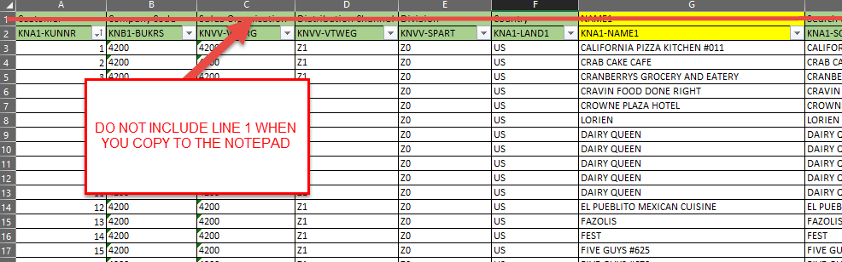
    - Save in .txt format
  + Open in SAP: /SCL/RUMLS_CUSTCREA
    - Upload the saved .txt file
      * You can and should also upload at the same time any other data files needed for the new accounts created
        + If you need to add time windows (Unloading Points), you can add them at this time as long as it is in TEXT (.txt) format
        + If you need to add Contact Persons, you can add them at this time in .txt format
        + If you need to add Partner functions (template in deck), you can add them at this time in .txt format
      * Click on DESKTOP
      * MAKE SURE TEST MODE BOX IS CHECKED
      * Click the execute button (green circle check)
      * **Run in TEST MODE FIRST (always!!!)**
      * 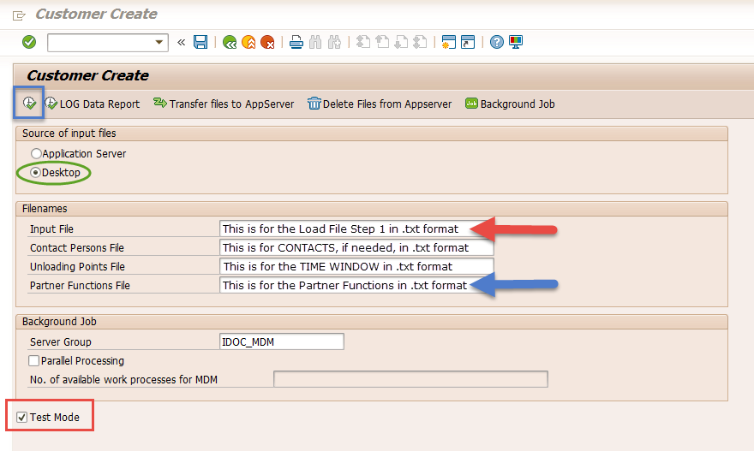
  + Check for any file errors, if errors occur:
    - Correct the load errors then save corrections in .txt file to reload
    - Common errors:
      * 4200/4250 values are mismatched
      * Typo errors, additional spacing in the AML, etc.
      * Different value is accidentally populated in the wrong data field
  + Rerun load in .txt TEST MODE to resolve errors
    - Errors still may be on the load, but if there were 300 accounts to be created and you have 3 accounts in error, move forward with the load at that point, if you have 60 errors out of the 300… something else is wrong and you WANT to take the time to determine the root cause of the error for so many accounts to error out)
    - 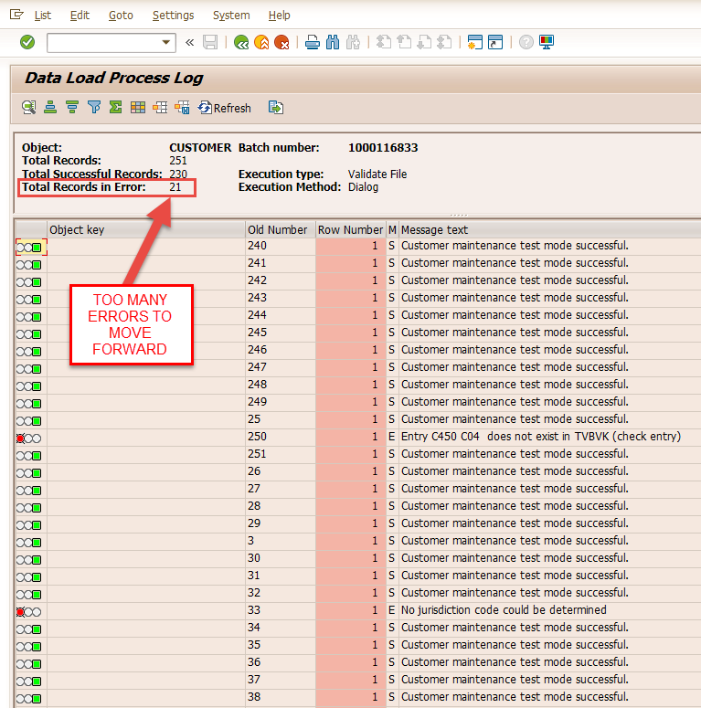 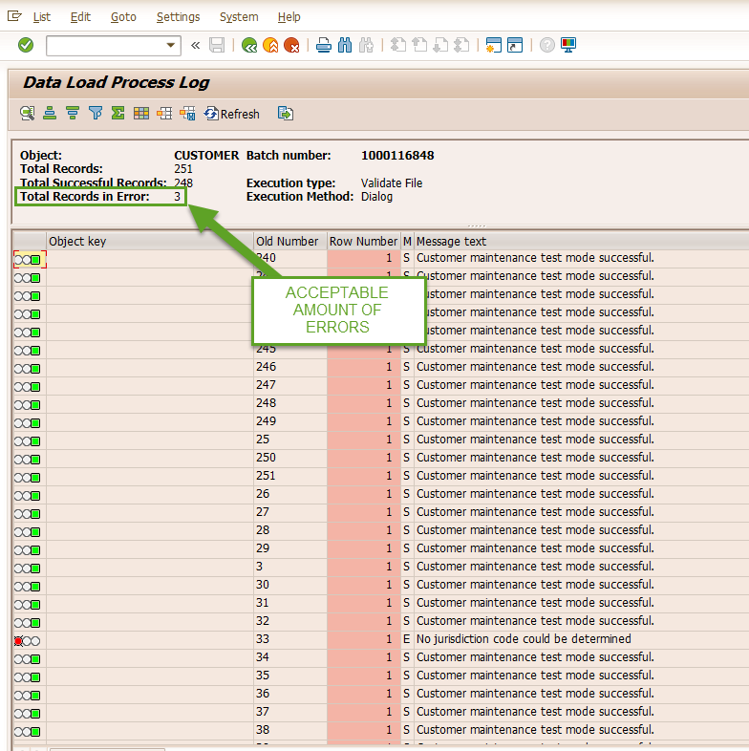
  + After TEST mode has been ran successfully with minimal errors, uncheck the TEST MODE box and run the load
    - This will take a much longer time to process, do not worry if it takes up to 10-15 minutes to process (for about 300 accounts)
  + When the load is completed, open the batch file and extract the data to add to the LOAD FILE Step 1
    - To Export:
      * 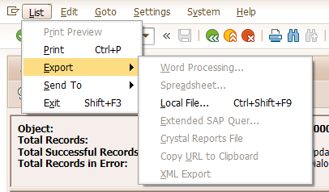
      * Select “In the clipboard”
      * Open a blank excel sheet and paste (CTL+V or right click paste)
      * Sort columns so that the old number aligns with the new account number to add to the LOAD FILE in the correct sequence
    - If there were accounts that could not be created, you will need to create them manually
      * Keep in mind that you will still need to keep the NEW account numbers in order that the “Old Number” was assigned to add it to you LOAD FILE for the correct account locations
    - 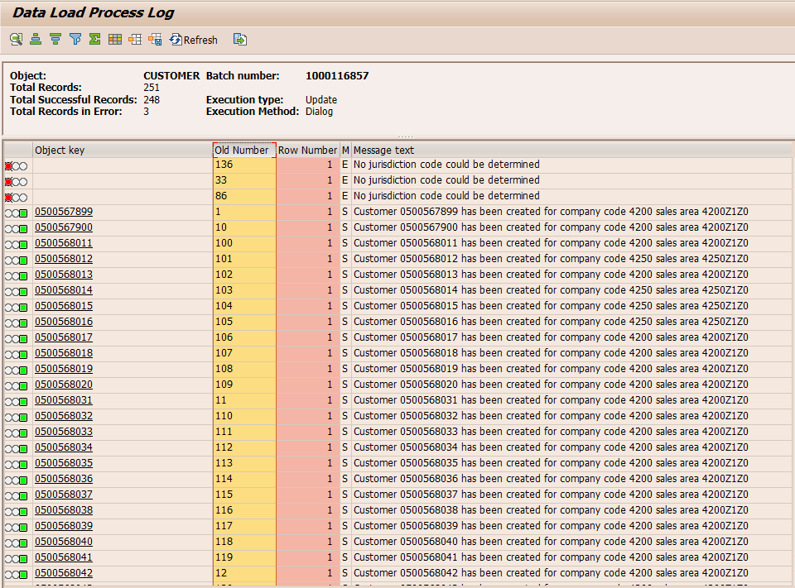
  + Manually create the accounts that could not be created in CMC and add that information to the LOAD FILE
  + Populate the Load Template worksheet with the final account numbers by referencing the original rote numbers assigned

**END CHECKLIST (TO DO)**

* Follow guideline on how to generate GEO Codes
* Follow guideline on how to maintain vehicle types
* Add any payer
* Add the partner functions
* Consider crossdock locations and add accordingly
* Transfer visit plans
* Add Phone number
* Add Time Window
* Do all Output conditions (VV31)
* After 5 business days, suppress ONLY old accounts unless field otherwise advises